MONTHLY UPDATE report TO THE MINISTRY OF FINANCE
  - march 2018

This report provides a summary view of PTAD’s key achievements and performance on its pension payments for the month. Further details and information on any aspect of this report is available upon request.
  - MONTHLY UPDATE report
The Executive Secretary PTAD, Sharon Ikeazor, in a group photograph with NDA 300 Level Accounting Officers during a recent 2day Pension Accounting and Computation Training at PTAD Head Quarters, Abuja.
  - march 2018
PTAD RE-ENROLLS AND PAYS PENSION ARREARS TO CIVIL SERVICE PENSIONERS
After long and lingering years without pension/gratuity for so many elderly citizens, PTAD has provided succor to 19,505 genuine Civil Service Pensioners who were wrongly dropped from the payroll prior to the establishment of PTAD. These pensioners, who were paid a total of N9.7B in arrears/gratuities between November 2016 and March 2018, were identified during the recently concluded verification of civil service pensioners in all the zones of the country.

For the first quarter of 2018, PTAD has ensured payment of N6.64billion to over 111,000 Civil Service pensioners including pension and gratuity to Civil Service pensioners as well as pension payment to Retired Federal Permanent Secretaries & Heads of Service under the Defined Benefit Scheme (DBS).
THE TABLE BELOW OUTLINES COMPLAINTS RESOLUTION UNDER THE CIVIL SECTOR IN THE FIRST QUARTER OF THE YEAR
COMPARATIVE ANALYSIS OF MONTHLY PERFORMANCE IN COMPUTATION

SN | COMPLAINTS RESOLUTION MARCH ACTIVITY FOR QUARTER 1 | JAN | FEB | MAR
1 | Letters Drafted | 152 | 161 | 151
2 | Complaints from the backlog of complaints on the Pensioner Complaint Management Portal | 77 | 1023 | 1105
3 | Review of Complaints from Lagos State Government | 0 | 0 | 80
4 | Review of Complaints from National Judicial Council | 0 | 0 | 127
5 | Request Forwarded To PSSD for Mobile Verification | 29 | 43 | 0
6 | Request Forwarded To PSSD for Scanning and updating of pensioners record | 9 | 89 | 12
7 | Submission of verified pensioners Complaint Forms not on payroll to Account | 88 | 35 | 16
8 | Call Log | 20 | 56 | 139
9 | Internal Memo | 22 | 0 | 15
SUMMARY OF MARCH, 2018 PENSION PAYMENT FOR THE FOUR (4) PENSION PAYING DEPARTMENTS
DEPARTMENTS | NUMBER OF PENSIONERS | AMOUNT UTILIZED FOR PAYMENTS OF PENSIONS AND GRATUITIES
CIPPD | 11,966 | 620,328,452.73
PaPD | 98,209 | 4,117,983,034.76
CSPD | 111,703 | 2,906,642,971.19
PPD | 16,055 | 558,036,667.13
TOTAL | 237,953 | 8,202,991,125.81
Note: There was a rise in pension payment for CSPD during the month of march as we were able to accommodate the payment of pension arrears to 376 pensioners from North West, South East, North East & South South Zones and the Resolved complaints of 90 pensioners in Batch 28 from the accumulated surpluses for the months of January and February 2018.

KEY ACTIVITIES/ACHIEVEMENTS FOR THE MONTH OF MARCH, 2018
Pension Administration | PARASTATAL PENSIONS  - Timely and successful payment of 98,209 pensioners on payroll, amounting to ₦4,117,983,034.76  - Continuous validation of the parastatals Pension and the Universities payroll to generate additional value for money. Through this, the Directorate is able to promptly remove deceased pensioners from the Payroll. Thus saving FGN money through elimination of fraud and unqualified persons on payroll.  CIVIL SERVICE PENSIONS  - Timely and successful payment of 111,703 pensioners on payroll, amounting to ₦2,906,642,971.19.  POLICE PENSIONS  - Timely and successful payment of 16,055 pensioners on payroll, amounting to ₦558, 036,667.13  CUSTOMS IMMIGRATIONS AND PRISONS PENSIONS  - Timely and successful payment of 11,966 pensioners on payroll, amounting to ₦620,328,452.73.  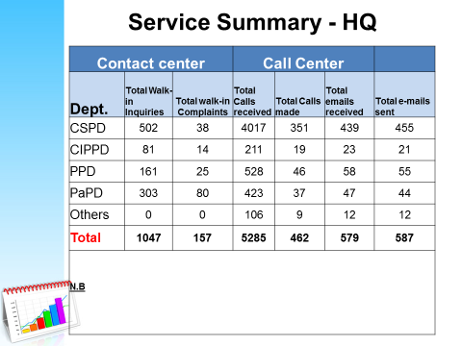
Verification | 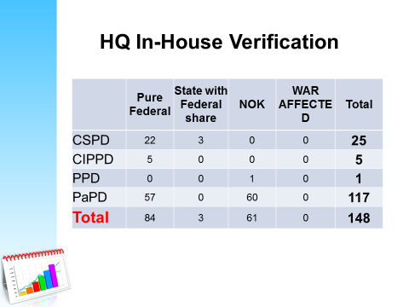  - PaPD staff were involved in the in house verification exercise of pensioners and NOKs that missed the field exercise, conducted between Nov, 2017 - Feb, 2018. The pensioner’s cut across all the defunct agencies that have been verified i.e. New Nigerian Newspapers, NITEL, Delta Steel Company, Federal Housing Authority, NICON, Nig-Reinsurance and NDA.
Stakeholder Communication & Engagement | - Meetings have taken place with the representatives of the Association of Federal Health Pensioners, Research Institutes Pensioners Union, Federal University Pensioners Association (FUPA) -Federal University of Technology Owerri Branch and some sector unions within the Nigerian Union of Pensioners.  - Similarly, meetings have been held with the management and pensioners of the New Nigeria Newspapers (NNN) and representatives of the Federal Ministry of Justice. All these engagements occur to improve communication between the Directorate and its stakeholders.
Information Technology | - Continue providing support to benefit computation of verified CSPD pensioners.  - Continue data Security Checks on PTAD Databases (Monitoring Audit trails and managing restrictions).  - Provide adequate IT support for PaPD verification exercise.  - Provided technical support to Operational Departments in processing March 2018 monthly pension
Organizational growth | - The Directorate has approved its Standard Operating Policy (SOP) documents for all processes/procedures and these are now being implemented by all departments. Training of staff has also began.  - The Directorate hosted NDA 300 Level Accounting Officers to a 2Day Training on Pension Accounting and Computation at our Head Quarters in Abuja.  - Presentation of Evaluation Report to the Tenders Board for ratification and approval for the award of the procurement of Consultancy firm for Design, Development and Implementation of Biometric Solution for PaPD verification has been done.
Compliance and Risk monitoring | A half a year compliance awareness plan on different topics ranging from code of ethics, corruption, anti-bribery and corruption, whistleblowing, public service rules, financial regulations etc. was prepared. The expectation is that PTAD staff at the end of the awareness program will be better educated on the Topics including but not limited to:  - Code of ethics: This will help outline and educate staff on the mission and values of PTAD and also the professional way to approach various issues.  - Whistleblowing policy: This will provide avenues for staff to report wrong doings in PTAD, as well as procedure and protection offered under the policy.  - Anti-Bribery and Corruption Policy: This policy spells out in clears terms, acts which are frowned upon and which amounts to bribery and corruption.  An email on data privacy and security was sent out to all staff, this email was followed by a “Clean Desk sweep” to check the level of compliance by members of staff. During the clean desk sweep, following was discovered:  - Staff leave important documents and files belonging to pensioners lying around at the close of work, giving room for fraud, as anyone can easily use the information in the files to call the pensioner and make demands to process their pension payment.  - Sensitive documents not being used are left around instead of being shredded, thereby littering the office.  Laptops are left on the table instead of being locked away in the cabinet giving room for theft. It is expected that by this continued communication and sweeps staff will be more aware of the possibility of data loss and fraud when they leave documents lying around and will be more cautious when handling a pensioner’s file or document.

