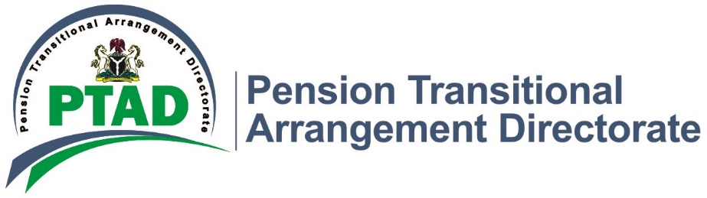
Press Release 19th September, 2019

NUP Appreciates PTAD, Pledges More Support

PTAD Executive Secretary, Dr. Chioma N Ejikeme has been assured of the continuous support of Nigeria Union of Pensioners (NUP). This assurance was given yesterday by the National leadership of the Nigeria Union of Pensioners (NUP) led by its National Deputy President, Alh. Musa Ayuba along with other National and Regional Executive members during a courtesy visit to the new Executive Secretary of PTAD Dr. (Mrs.) Chioma Ejikeme in Abuja.
The Union National Deputy President commended the Directorate’s effort to put smile on their faces. Alhaji Musa Ayuba recounted their frustration in the past but with the creation of PTAD the story has changed for the better. He said, “Before the advent of PTAD, there was no official record for pensioners, no database anywhere, but today, that has become a thing of the past. Endless and stressful verification is also gone for the better. Now pensioners are better recognized and treated with some respect. Monthly pension is being paid as and at when due in the last 4 years. Kudos to President Muhammadu Buhari’s administration, kudos to PTAD”
He assured the Executive Secretary of the Union’s support, solidarity and encouragement towards achieving the best for pensioners under the Defined Benefit Scheme (DBS). He urged the Executive Secretary to always carry the Union along in all PTAD’s decisions concerning pensioners.
He also asked the Executive Secretary to give them timely information so that the union can effectively support and mobilise for all PTAD activities. He pleaded with her to address the issue of death benefit payment to Next of Kins and payment of the outstanding balance of 33% pension arrears to the Parastatal

pensioners. He also urged her to help the Union present before the government the payment of minimum pension as provided for in the constitution.
The Executive Secretary, PTAD, Dr. Chioma N. Ejikeme said she was highly honored by the Union’s visit. She appealed to the Union not to relent in their support of the Directorate. She said one of the reasons for the ongoing verification for the Parastatal Pensioners is to compute their rightful pension benefits and have a credible database of all pensioners
She also promised to build on the legacy laid by Barr. Sharon Ikeazor and work with the Union to further improve their welfare.

SIGNED
MANAGEMENT

