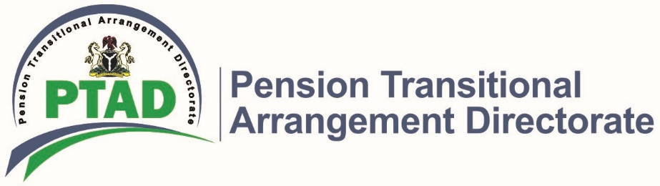
ANNOUNCEMENT

PTAD Commences the Seventh Phase of Parastatals Pensioner Verification Exercise for Pensioners under the Defined Benefit Scheme

The Executive Secretary, PTAD wishes to announce the commencement of the Seventh phase of the Parastatal Pensioner Verification Exercise for pensioners and Next of Kin (NoK) of all Federally Funded Parastatals, Agencies and Institutes under the Defined Benefit Scheme (DBS) in the North Central geopolitical zone.

The verification exercise will cover retirees of 270 agencies including:

- Federal Universities
- Polytechnics
- Colleges of Education
- Teaching Hospitals
- Medical Centers
- Power Holding Company of Nigeria
- Nigeria Railway Corporation
- Nigeria Postal Services
- Research Institutes and other Treasury funded Parastatals, Agencies and Institutes.

The exercise will also cover retirees of the defunct/privatized agencies who are yet to be verified such as:

- Aluminum Smelter Company of Nigeria (ALSCON)
- Nigeria Aviation Handling Company (NAHCO)
- Assurance Bank
- Nigerian National Shipping Line (NNSL)

This exercise will hold at the following centers from 8am – 4pm:
Centre | Venue. | Date
Ilorin | Ultimate multipurpose Hall, New Yidi Road. | October 21 – 30, 2019  October 21 - 30, 2019
Minna | Posh Garden Marquee, Plot 12 Eastern Bye-Pass (Beside Hausa Block Industry)
Lokoja | Kafas Multipurpose Hall. No. 193 Okene/Kabba Lokongoma Phase II. | October 21 – November 2, 2019
Jos | Usiju World Limited, Plot 731 Apollo Crescent GRA | October 21 – November 2, 2019

In order to be verified, it is mandatory for all pensioners & Next of Kin (NoK) to provide the original and photocopies of the following documents:

- Letter of First Appointment.
- Letter of Last Promotion.
- Approved Letter of Retirement.
- Evidence of Change of Name (where applicable).
- Evidence of Transfer/Merger of Service (where applicable).
- BVN Registration Slip with clear picture (stamped and signed by the bank).
- Original and Stamped Bank Statement for the last one month and/or e-Token as applicable
- 1 recent coloured passport photograph
- Audited and Stamped Computation Sheet.
- Letter of Confirmation of appointment.
- Valid means of Identification (Driving License, Int’l Passport, National ID Card or Voters Registration Card).
- Last Pay Slip
- Pensioner Birth Certificate.

In addition to the aforementioned documents, Next of Kins (NoKs) are also required to provide the following mandatory documents:

- Death Certificate of the Deceased from a Government Hospital or National Population Commission.
- Letter of Administration from High Court.
- Single/Joint Application by the NOK(s); as listed on the Letter of Administration
- Marriage Certificate (for Spouses).
- Original and Stamped Bank Statement of the deceased pensioner from retirement to date and/or e-Token as applicable.
- Duly signed and stamped NUBAN Single/Joint Bank Account Statement of the NOK(s), with Bank Logo.
- BVN Registration Slip with clear picture (stamped and signed by the bank).
- 1 coloured Passport Photograph of each NOK.
- Birth certificate of the NoK
- Valid means of Identification (Driving License, Int’l Passport, National ID Card or Voters Registration Card).

Pensioners are also to NOTE as follows:
- All pensioners currently living outside the country will be verified whenever they visit the country provided they show proof of residency outside Nigeria. Such proof should be provided in advance via PTAD email: info@ptad.gov.ng.
- Mobile Verification will be conducted for sick and infirm Pensioners. The original documents of the pensioners must be brought to the verification venue together with proof of infirmity for authentication, before mobile verification can be scheduled.
- This verification exercise does not include Customs, Immigration and Prisons Pensioners, Civil Service Pensioners as well as Police pensioners as well as Parastatals Pensioners who had already been verified by PTAD.
- All Letters of Introduction for new enrolees (those not currently on payroll) must be personally signed by the Chief Executive Officer of the Agency, to be acceptable for verification.

NOTICE:
Pensioners should please note that they do not have to travel to the state they retired from to be verified. They can be verified at any of the centres in the geo-political zones where they currently reside.

For further inquiries contact:
Toll Free Lines: Phone No (Charges Apply):0800-CALL-PTAD (0800-2255-7823) +234(0)9-462-1700,
+234(0)8136048117
Email:info@ptad.gov.ng, complaints@ptad.gov.ng
Follow Us on Twitter: @PTADNigeria. Visit our website www.ptad.gov.ng for more information.

FRAUD ALERT!

Pensioners are advised to be wary of FRAUDSTERS as Pension payment is free. PTAD will NEVER request for cash to process your pension. Please call 08144607574 or email actu@ptad.gov.ng to report suspicious phone calls or messages. PTAD will handover such suspects to security agencies for prosecution.

Signed:
DR. CHIOMA EJIKEME
Executive Secretary.

