  - MONTHLY UPDATE
The Pension Transitional Arrangement Directorate (PTAD) has concluded the verification of all Parastatal Pensioners with the Federal Capital Territory Parastatal Verification Exercise which commenced on Monday, November 18th and ended on the 23rd of November, 2019.

The verification exercise was held in three centres within the FCT namely:
Centre 1- H&C Event Centre, behind Zoological garden Garki, Area 1 Abuja
Centre 2- Holy Trinity Event centre, 36 Aguiyi Ironsi Street, Maitama, Abuja
Centre 3 – NAOWA Event Centre, Mambilla Gowon Barrack, Asokoro Abuja.

The Directorate verified 3,065 Parastatal Pensioners under the Defined Benefit Scheme in the FCT. The exercise included capturing eligible Pensioners’ biometrics and digitalization of the employment records into comprehensive database.

The Executive Secretary of PTAD, Dr. Chioma Ejikeme appreciated members of the National Assembly, particularly the Committee Chairman on Pensions, Rt. Hon. Kabiru Alhasaan Rurum and his Deputy Hon. Bamidele Salam for their concern for the senior citizens and support since the inception of the 9th assembly.

In line with PTAD’s service charter, the pensioners were treated with respect and empathy. The exercise was conducted in conducive environments where pensioners were comfortably seated and provided with lunch and medical facility to take care of any emergencies.

PTAD CONCLUDES VERIFICATION FOR PARASTATAL PENSIONERS IN F.C.T
  - November 2019
PTAD AWARDED FIRST POSITION AMONG 89 PARASTATALS

The Pension Transitional Arrangement Directorate has been awarded 1st position out of the 89 Parastatals under different sectors that were examined on “Ethics/ Integrity Compliance & Administrative Competence” by the Independent Corrupt Practices and other Related Offence Commission (ICPC) in Federal Capital Territory.

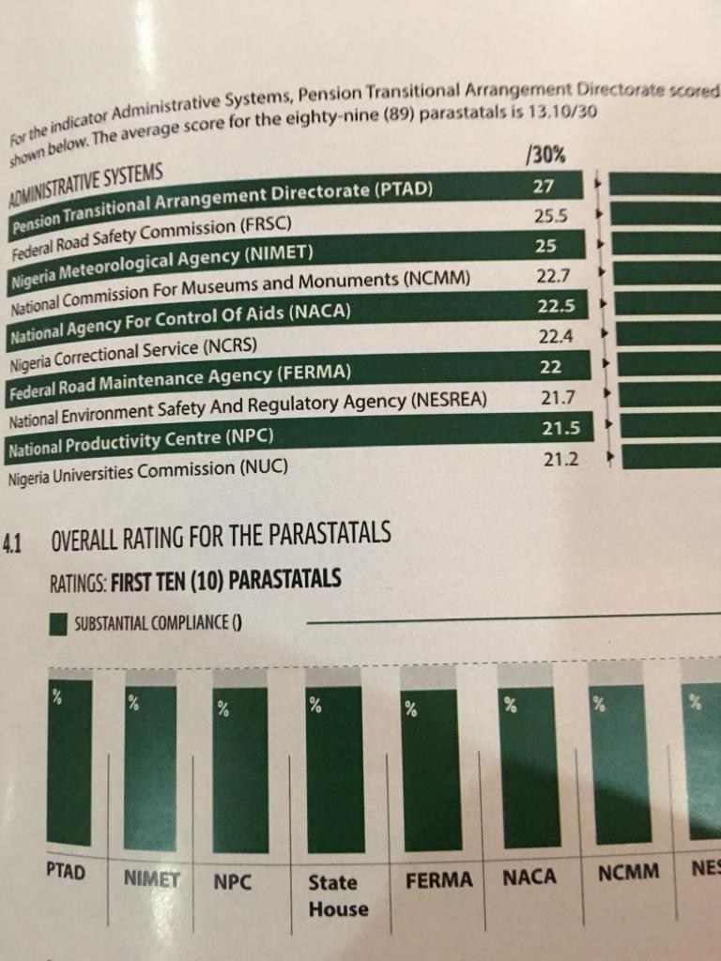PTAD was adjudged the best under three categories to win the 1st position:
- The Parastatal with the best Administrative Systems
- The Parastatal with the best Management Culture and Structure,
- The Parastatal with the best Financial Management System.
The Directorate was awarded the overall best with full level of compliance in all the areas reviewed.
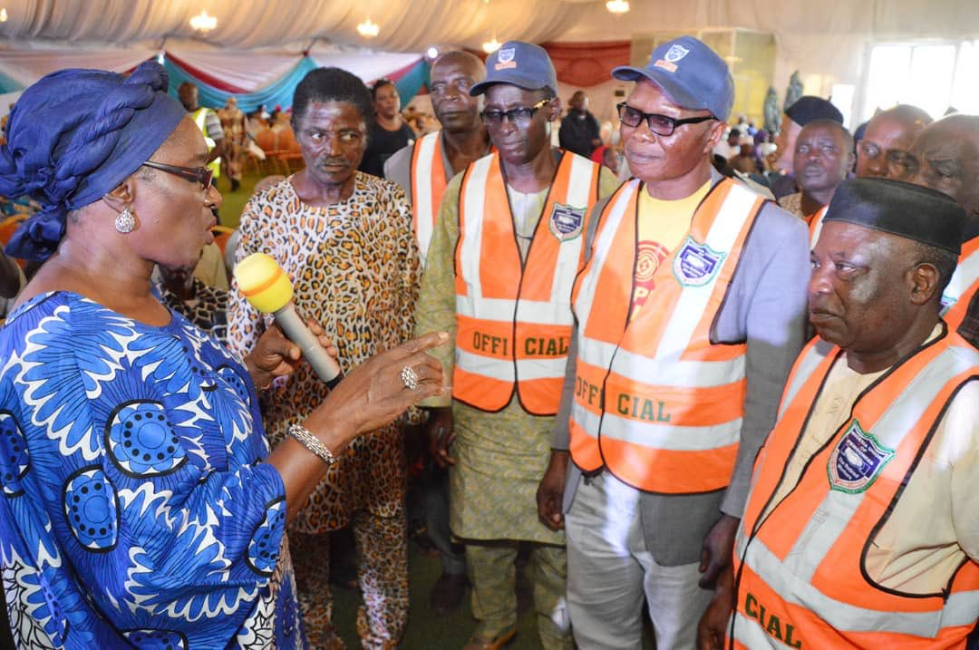
This was made known to the public on Monday 18th November 2019 in Abuja.
Executive Secretary, Dr. Chioma Ejikeme addressing the National Union of Pensioners executives who came out to help pensioners during the verification exercise in Jos, Nigeria.
The House Committee Chairman on Pensions, Rt. Hon. Kabiru Alhassan Rurum and the Deputy Chairman, Hon. Bamidele Salam during National Assembly oversight visit at one of the venues of the Parastatals Verification exercise in Maitama, Abuja.

