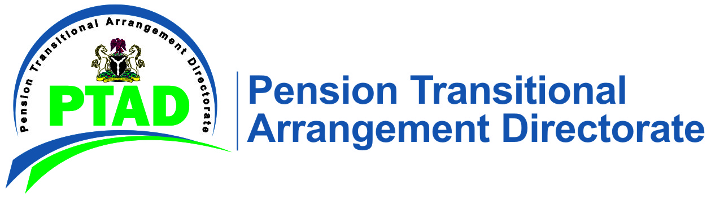
17th February 2021
PRESS RELEASE

RESUMPTION OF THE POSTPONED MOP-UP/IN HOUSE VERIFICATION

PTAD wishes to inform our esteemed Pensioners/NoKs that the mop up verification exercise earlier scheduled for 18th January, 2021 will now commence from 17th February to 23rd February 2021 at the Directorate’s Headquarters Abuja. This exercise is for Pensioners who have already submitted their documents for consideration and have been invited to be verified.
The continuous In-House verification at the Head Office and the Directorate’s Lagos Regional Office will resume immediately after the mop-up exercise.
Pensioners who are yet to submit their documents for consideration are encouraged to do so now. They can submit their documents at PTAD Headquarters in Abuja, PTAD State Offices or scan the documents and send via email to: verifications@ptad.gov.ng. or by regular mail to:
The Executive Secretary
Pension Transitional Arrangement Directorate
22, Katsina Ala Crescent, Off Yedseram Street, Maitama, Abuja.

Bearing in mind that we are still dealing with the Covid-19 pandemic and the need for adequate safety measures, the mop up/ In-House verification exercise is strictly based on APPOINTMENT ONLY. Following submission of documents, Pensioners will be invited on a GIVEN DATE and TIME

For further inquiries call 09-4621700 (Rates Apply) or 0800-2255-7823 (Toll Free). For more information on PTAD and its activities, please log on to www.ptad.gov.ng.

PTAD will NEVER request for cash to process your pension. Please call 08144607574 or email actu@ptad.gov.ng to report suspicious phone calls or messages.

Signed
Management

