MONTHLY UPDATE REPORT
PTAD HOLDS MEETING WITH INLAND STEEL ROLLING MILL PENSIONERS ON PENSION PAYMENTS

The Pension Transitional Arrangement Directorate (PTAD) recently held a meeting with the Union representatives of the Inland Steel Rolling Mills of Jos, Katsina and Oshogbo. The meeting which took place at the Executive Secretary’s Conference Room of the Directorate’s headquarters in Abuja on the 11th of July 2019 was to provide an update on the re-computation of pension benefits in line with the approved pension policy guidelines.
Other areas of discussion touched on the payment of death benefits to verified Next of Kins (NoKs) of the deceased pensioners. PTAD informed the Union that 17 NoKs had been paid while computation was in progress for the remaining NoKs to be paid off. The representatives were also informed that letters had been sent to the Steel Rolling pensioners to notify them of the adjustments in their pension payments as an aftermath of the re-computation exercise.
The Union chairman, Oguntona Benson thanked the PTAD management for briefing them on the outcome of the re-computation exercise and its plans going forward.

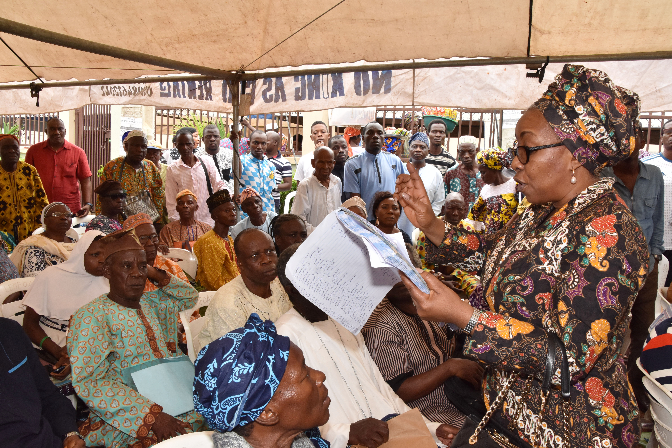
JULY 2019

PTAD CONDUCTS SOUTH-WEST VERIFICATION FOR PENSIONERS UNDER PARASTATAL PENSION DEPARTMENT
The Pension Transitional Arrangement Directorate continued its Nationwide Verification Exercise for all retirees and NOKs of Treasury Funded Parastatals and defunct agencies in the South West region of Nigeria.
The exercise took place between the 15th of July and 24th of July, 2019 across the region and had centres in Ibadan, Oyo State; Oshogbo, Osun State and Abeokuta, Ogun State. This verification exercise is meant to also accommodate ex-workers of the Nigerian Aviation Handling Company (NAHCO); Assurance Bank; Nigerian National Shipping Line (NNSL) and Aluminium Smelter Company of Nigerian (ALSCON).
The expected number of pensioners to be verified in the South West is Sixteen Thousand Seven Hundred and Two (16,702).
PTAD is expected to sustain its desire to capture pensioners and Next of Kins (NoKs) from the North East and South East zones in August 2019.

PENSIONERS LAUD PTAD OVER SMOOTH BIOMETRIC VERIFICATION EXERCISE
Pensioners have lauded the new dimension put in place in the ongoing biometric verification of Federal Civil Servants retirees being conducted by the Pension Transitional Arrangement Directorate (PTAD).
The new dimension in verification, according to them, has curbed the activities of corrupt government officials who engaged in the diversion of pension funds for personal use as the accurate database has been created for prompt payment of their pension allowance.
Some of the pensioners who spoke with Vanguard at the Nigeria Union of Pensioners Events Hall, Agbarigo, Onireke area, Ibadan during the verification exercise, expressed happiness over what they called the ‘change agenda’ of the Executive Secretary of the organization. In his remark, a federal government pensioner, Mr Kunle Ajani, noted that pension administration in Nigeria, especially as it concerns government pensioners, was nothing to write home about. “The system was notorious for fraud, pension funds being diverted by government officials.” “The situation has changed following the measures and structures put in place by the PTAD management which has sanitized the system and restored hope to pensioners.”
Another pensioner, Mr Femi Ojo, who described the exercise as very smooth commended the management PTAD for putting up a water-tight arrangement for the smooth conduct of the exercise
https://www.vanguardngr.com/2019/07/pensioners-laud-ptad-over-smooth-biometric-verification-exercise/
The Executive Secretary, Sharon Ikeazor addressing pensioners in Abeokuta during the PaPD verification

