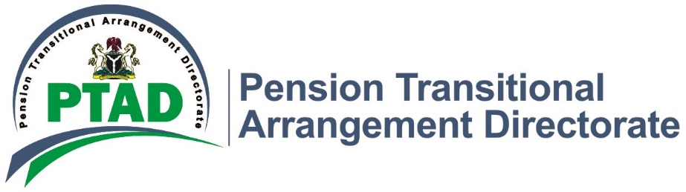

PTAD Clears Pension Arrears of 16,210 Pensioners, Pays N6.2bn.

The Pension Transitional Arrangement Directorate (PTAD) has embarked on an expanded re-validation and re-computation exercise in a bid to clear all pension arrears and resolve all complaints of short payments and outstanding gratuities for the Civil Service Pensioners and their Next of Kin (NoK). So far, the Directorate has been able to review, compute, recompute and pay N6.2bn to 16,210 pensioners as a result of this project.
This is in fulfilment of the promise made by the Executive Secretary, Dr. Chioma Ejikeme at the Directorate’s Press Conference in September, 2020 where she declared a State of Emergency on the payment of outstanding entitlements to Pensioners, and set-up an expanded project team to ramp up on the computation of benefits for all verified Civil Service Pensioners.
According to the Executive Secretary, the project is targeted at reducing the number of complaints received by the Directorate on short payments, qualified pensioners not on payroll and other outstanding benefits to the pensioners and the Next of Kin of deceased pensioners.
During the exercise (September 2020 – March 2021) a total of 46,284 pensioners’ files were reviewed for end to end quality assurance. A total sum of N6.2 billion Naira has been paid as arrears of gratuity, monthly payments and one-off payments to 16,210 Pensioners/Nok that are qualified for the payment after the computation. Over 1,000 qualified pensioners not on payroll post verification have been put on the payroll and their arrears paid.
A key aspect of the project geared towards continuous resolution of complaints was that it ensured that pensioners who have outstanding documents e.g., bank statements, BVN and other required documents were contacted so as to resolve their complaints effectively. Calls were put across to the affected pensioners; letters were also written requesting them to forward such documents to the Directorate for the resolution of their complaints
Dr. Chioma Ejikeme assured that by the end of the 2nd quarter of 2021, all issues relating to short payments, gratuity and other forms of arrears for Civil Service Pensioners would be settled. She further assured that pensioners’ welfare and wellbeing are of utmost priority to her.

Signed
Management.

