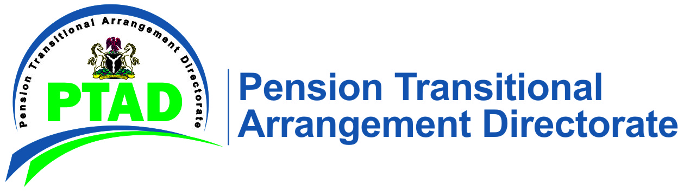

PRESS RELEASE 2nd May, 2021

No DBS Pensioners will be Left Out of the Consequential Adjustment.

The attention of the Pension Transitional Arrangement Directorate (PTAD) has been drawn to the statement issued by the Federal Parastatals and Private Sector Pensioners Association of Nigeria (FEPPAN) in the Vanguard Newspaper (online edition) of 1st May 2021 in which the Association alleged that it had been left out of the consequential pension adjustment approved by President Muhammadu Buhari.

We would like to state emphatically that Mr. President's approval under reference covers all pensioners under the Defined Benefit Scheme (DBS) including parastatal pensioners who constitute the membership of FEPPAN, and does not discriminate against any category of pensioners. For the avoidance of doubt, the Directorate has already computed the entitlements of all its pensioners and will commence the immediate implementation of the consequential increment as approved by Mr. President. This, therefore, renders any call of potential engagement of any Federal Government agency by FEPPAN irrelevant as all its members are covered under the DBS umbrella as stated in the circular released by the National Salaries Wages and Incomes Commission (NSWIC).

We will, therefore, like to use this opportunity to continue to appeal to the leadership of all pension unions to avail themselves of the freedom of information offered by the Directorate pertaining to all pension matters in order to avoid the unfortunate misconception of laudable government policies as was evident in the news story mentioned earlier.

You can contact PTAD on:

080-CALL-PTAD (0800-2255-7823) Toll Free

09-4621700, 09-4621722 Rates apply

Website: www.ptad.gov.ng

Complaints Resolution: compliments@ptad.gov.ng

Enquiries: info@ptad.gov.ng

Twitter: @PTADNigeria

Facebook: www.facebook.com/ptadnigeria

should you require further information.

Signed

Management.

