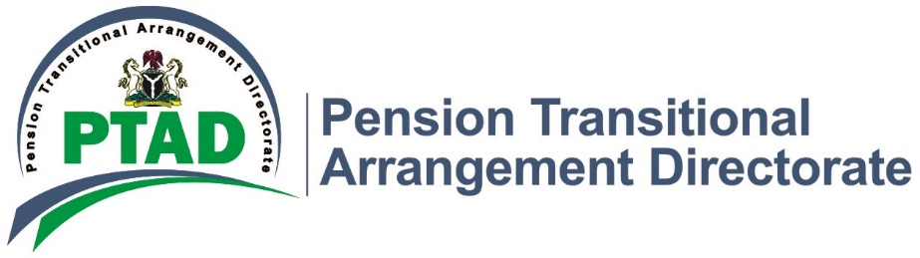
PTAD/CCU/02/II 5th May, 2022.

Press Release.

Clarification on the Applicability of 33% Pension Increase to Ex-PHCN Retirees.

The attention of PTAD Management has been drawn to a growing agitation by some group of PHCN Pensioners known as concerned PHCN Pensioners
They are alleging PTAD has colluded with some “powerful individuals” to deprive them of the 33% pension increment as approved by the Federal Government in 2010.
For the records, President Muhammadu Buhari is very committed to the welfare of pensioners and has consistently demonstrated this by approving the payment of outstanding pension arrears and regular payment of monthly pensions.
We would like to state unequivocally, that the National Salaries, Incomes & Wages Commission, the Federal Government agency responsible for policy statement on emoluments including pensions had directed via a letter of approval Ref: SWC/S/04/S.542/26 of 26th September 2014, that the retired staff of the defunct Power Holding Company of Nigeria (PHCN) are not entitled to the pension increase of 33%. This is because PHCN pensioners were already on a special salary structure before the pension review for Pensioners who while in service were on one of the Harmonized Salary Structures of the Federal Public Service.
It should be noted that PHCN Pensioners took the Federal Government to the National Industrial Court (NIC) Abuja on this issue. After several engagements, President Buhari approved the implementation of 9.7% increase in the pensions of Ex-PHCN Retirees under the Defined Benefit Scheme (DBS). This approval was used as an out- of -court settlement in order to put an end to the suit at NIC, Abuja.
Following the approval of the President, via approval letter Ref:(SWC/S/04/S.557/III/546) of 7th May, 2021, the 9.7% increment was implemented with effect from 1st June, 2016 and the arrears paid in December 2021 to all eligible Ex-PHCN Retirees. It is therefore preposterous and uncalled for that this group wants to conveniently forget the amicable agreement reached by all parties and arm-twist the Federal Government to make claims on the 33% pension increment.
Other related issues as it concerns this group of pensioners have since been communicated to the Coordinator of the Concerned PHCN Pensioners, Mr. Dunmoye Muritala Oladimeji via a letter dated March 17, 2021 with Ref: (PTAD/PaPD/231/VolII/263).
PTAD will continue to give priority to the welfare of Defined Benefit Scheme Pensioners.
Signed
Management

